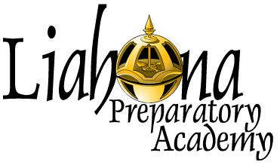
For Office Use Only:

Received Date:___________

Approval Date: ___________

2464 W 450 S Pleasant Grove, UT 84062
Office: (801) 785-7850 Fax: (801) 406-0071

PROCTOR CERTIFICATION FORM
This form is to be filled out by the proctor and returned to Liahona at one of the following:
FAX: (801) 406-0071
MAIL: 2464 W 450 S Pleasant Grove, UT 84062.

Once we receive your completed form, you will be notified concerning your approval status within five business days.
This certification will be valid for one school year, at which point you will need to complete a new form to remain a certified proctor for our school.
This form MAY NOT be completed by anyone other than the person applying to become a certified proctor. If anyone other than the proctor fills it out, the form will become invalid and the proctor will be immediately rejected.
Proctor Name:________________________________________________________
Address: _________________________________________________________________________________
Street City State Zip

Phone Number: _____________________ E-Mail Address:___________________
Name of proctoring facility:________________ Phone Number: ______________
Address: _________________________________________________________________________________
Street City State Zip

Student Name: ___________________ Student Phone Number: ______________

(Continued on back)

Proctors may NOT be any of the following:
- Relative or friend of student
- Employer of student
- Personal tutor of student
- Ecclesiastical leader if related to the student
- Athletic Coach, assistant coach, athletic administrator, or athletic academic counselor
- Someone with vested interest in the student’s eligibility to compete in extracurricular activities (i.e. sports, theater, choir, etc.)

➢ I certify that none of the above apply to me. INITIALS: __________
Please select your title from the list below:
 Guidance Counselor/counseling staff
 Certified teacher
 School Principal or vice principal
 Librarian
 Superintendent or other administrator
 Principal or faculty of an LDS seminary or institute
 Embassy education officer
 Military base/station education officer
 Local college testing center staff or administration
- Other

If you feel your situation allows you to proctor and is not listed above, please call Liahona Academy at 801-785-7850.
Enclosed with this certification form, you will find our exam policies and procedures. Please review them and initial below.

➢ I certify that I have read the above policies and procedures and that I will follow them to the best of my ability. INITIALS: __________
➢ I certify that I have completed this form for myself to become a certified proctor with Liahona Academy. INITIALS: __________
➢ I certify that all information is accurate and that I have not intentionally provided false or misleading information. INITIALS: __________

____________________________________________________________________________________________ Signature of Proctor Printed Name of Proctor Date

